Jason Mejia 7/9/20

CSC336 Project 2

**Family Relations – II**

Problem:

In this project we need to store information in the database using a java application. Since I am using MySQL workbench, I have to find a way to interact with MySQL by using java. From the previous assignment creating the tables such Persons, Family, grandparents and now adding more tables, it needs to be done in java. The given tables are Brother, Sister, Brother/Sister, and Husband/Wife. These tables are needed to fine the tuples for the table Sister-in-law. And solving the relational algebra for the table Sister-in-law.

Solution:

I am using Eclipse as my java application for the project. Now I have to use JDBC which will be used to connect to the database I am using in MySQL. Once we are connected to the database we can input the data we need. For the tables such as Persons, Family and grandparents are being used again from the first assignment. Now we are adding the values for the tables Brother, Sister, Brother/Sister, and Husband/Wife. For Sister-in-law we used the tables Brother, Sister, and Husband/Wife relationships to find the tuples for this table. For certain relationships such as being a wife to a husband that has multiple siblings, we used the tables brother and husband/wife. If a sister has brothers that are married then I will use the tables sister and husband/wife for that relationship.

What couldn’t achieve in this assignment was putting proper constructors for the classes and the proper functions required for the project.

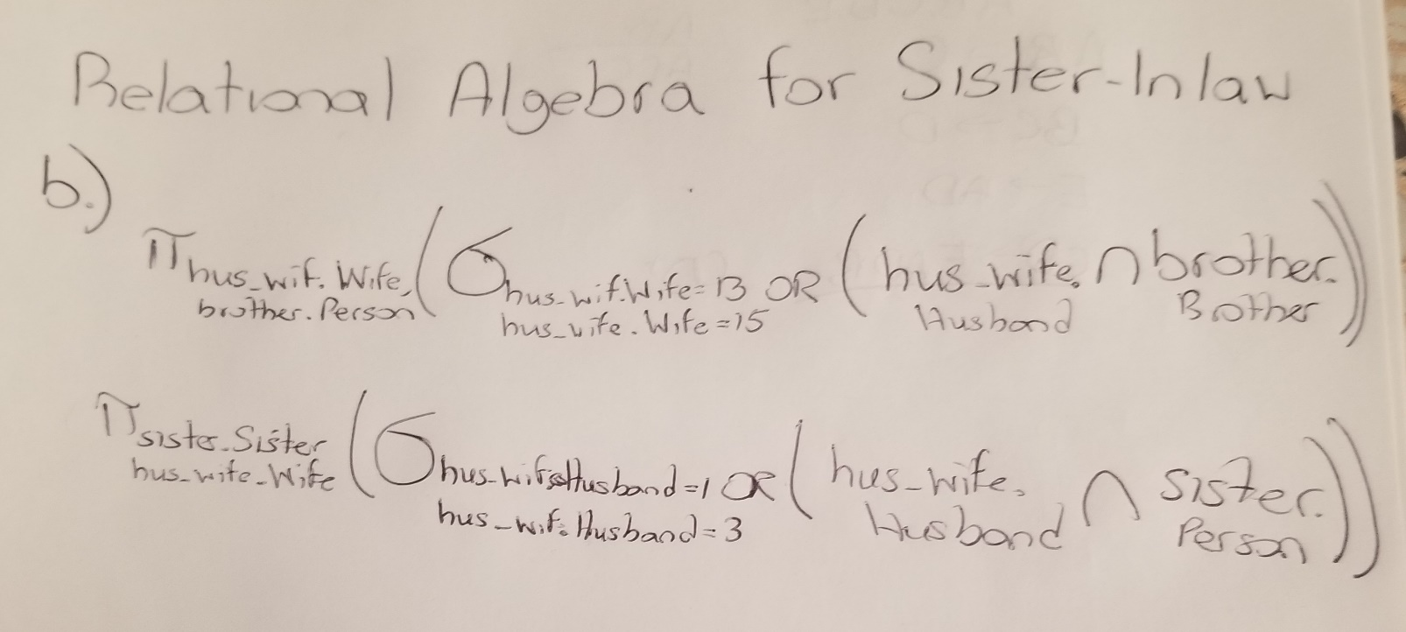

**Code:**

**Persons.java**

**package** relations;

**import** java.sql.*;

**public** **class** Persons {

**public** **static** **void** main(String[] args) {

String url = "jdbc:mysql://localhost:3306/people";

String username = "root";

String password = "Something11";

**try** {

// Connecting to the database from MySQL workbench

System.***out***.println("Connecting to a selected database...");

Connection myConn = DriverManager.*getConnection*(url, username, password);

System.***out***.println("Connected database successfully...");

Statement myStmt = myConn.createStatement();

//Here we started to create the first table Persons, which provide the number  
 of people to rest of the tables.

String sql = "CREATE TABLE Persons " +

"(ID INT PRIMARY KEY, " +

"Name VARCHAR(20), " +

"DOB VARCHAR(20) DEFAULT 'Unknown', " +

"Gender VARCHAR(1) CHECK(Gender = 'M' OR Gender = 'F')) ";

myStmt.executeUpdate(sql);

System.***out***.println("Created table in given database...");

//Inserting the values into the table

String insert = "INSERT INTO Persons VALUES(1, 'Jason', '11/30/1996', 'M') ";

myStmt.executeUpdate(insert);

insert = "INSERT INTO Persons VALUES(2, 'Nancy', '12/01/1989', 'F') ";

myStmt.executeUpdate(insert);

insert = "INSERT INTO Persons VALUES(3, 'Alfredo', '03/03/1987', 'M') ";

myStmt.executeUpdate(insert);

insert = "INSERT INTO Persons VALUES(4, 'Raquel', '04/27/1961', 'F') ";

myStmt.executeUpdate(insert);

insert = "INSERT INTO Persons VALUES(5, 'Giselo', '05/07/1960', 'M') ";

myStmt.executeUpdate(insert);

insert = "INSERT INTO Persons VALUES(6, 'Evelyn', '08/16/2012', 'F') ";

myStmt.executeUpdate(insert);

insert = "INSERT INTO Persons VALUES(7, 'Julian', '11/29/2014', 'M') ";

myStmt.executeUpdate(insert);

insert = "INSERT INTO Persons VALUES(8, 'Chris', '12/02/1989', 'M') ";

myStmt.executeUpdate(insert);

insert = "INSERT INTO Persons VALUES(9, 'Irene', '02/16/1908', 'F') ";

myStmt.executeUpdate(insert);

insert = "INSERT INTO Persons VALUES(10, 'Hector', '6/28/1908', 'M') ";

myStmt.executeUpdate(insert);

insert = "INSERT INTO Persons VALUES(11, 'Bertha', '6/28/1943', 'F') ";

myStmt.executeUpdate(insert);

insert = "INSERT INTO Persons VALUES(12, 'Michael', '6/28/1943', 'M') ";

myStmt.executeUpdate(insert);

insert = "INSERT INTO Persons VALUES(13, 'Lisa', '8/15/1996', 'F') ";

myStmt.executeUpdate(insert);

insert = "INSERT INTO Persons VALUES(14, 'Oliver', '3/21/2021', 'M') ";

myStmt.executeUpdate(insert);

insert = "INSERT INTO Persons VALUES(15, 'Kim', '3/4/1987', 'F') ";

myStmt.executeUpdate(insert);

System.***out***.println("Inserted records into the table...");

// This is where we would be calling the table and see all the information

ResultSet myRs = myStmt.executeQuery("select * from Persons");

**while** (myRs.next()) {

**int** id = myRs.getInt("ID");

String name = myRs.getString("Name");

String dob = myRs.getString("DOB");

String gender = myRs.getString("Gender");

System.***out***.println("ID:" + id +

", Name:" + name +

", DOB:" + dob +

", Gender:" + gender);

}

}

**catch** (Exception exc) {

exc.printStackTrace();

}

}

}

**Child.java**

**package** relations;

**import** java.sql.*;

**public** **class** Child **extends** Persons {

**public** **static** **void** main(String[] args) {

String url = "jdbc:mysql://localhost:3306/people";

String username = "root";

String password = "Something11";

**try** {

//Connecting to the database for the class Child

System.***out***.println("Connecting to a selected database...");

Connection myConn = DriverManager.*getConnection*(url, username, password);

System.***out***.println("Connected database successfully...");

Statement myStmt = myConn.createStatement();

ResultSet rs;

//Creating the table Family to see the parents of a child

String family = "CREATE TABLE Family " +

"(Child INT, " +

"Father INT, " +

"Mother INT, " +

"PRIMARY KEY (Child), " +

"FOREIGN KEY (Child) REFERENCES Persons(ID)," +

"FOREIGN KEY (Father) REFERENCES Persons(ID)," +

"FOREIGN KEY (Mother) REFERENCES Persons(ID))" ;

myStmt.executeUpdate(family);

System.***out***.println("Created table Family in given database...");

//Inserting the values of child and parent in the table

String finsert = "INSERT INTO Family VALUES(1, 5, 4)";

myStmt.executeUpdate(finsert);

finsert = "INSERT INTO Family VALUES(2, 5, 4)";

myStmt.executeUpdate(finsert);

finsert = "INSERT INTO Family VALUES(3, 5, 4)";

myStmt.executeUpdate(finsert);

finsert = "INSERT INTO Family VALUES(6, 8, 2)";

myStmt.executeUpdate(finsert);

finsert = "INSERT INTO Family VALUES(7, 8, 2)";

myStmt.executeUpdate(finsert);

finsert = "INSERT INTO Family VALUES(5, 10, 9)";

myStmt.executeUpdate(finsert);

finsert = "INSERT INTO Family VALUES(4, 12, 11)";

myStmt.executeUpdate(finsert);

finsert = "INSERT INTO Family VALUES(14, 1, 13)";

myStmt.executeUpdate(finsert);

System.***out***.println("Inserted records into the table family...");

//Here the results of the table are printed out.

ResultSet myRs = myStmt.executeQuery("select * from Family");

**while** (myRs.next()) {

**int** child = myRs.getInt("Child");

**int** father = myRs.getInt("Father");

**int** mother = myRs.getInt("Mother");

System.***out***.println("Child:" + child +

", Father:" + father +

", Mother:" + mother);

}

/*

* A stored procedure is created to give the children from the parents inputed

* In the procedure we are using the tables Persons and Family to find the  
 children

*/

String children="CREATE PROCEDURE ChildrenOf(IN Mother INT, IN Father INT)\n"+

"BEGIN\r\n" +

" SELECT Family.Child, Persons.Name, Persons.Gender\r\n" +

" FROM Family\r\n" +

" JOIN Persons\r\n" +

" ON Persons.ID = Family.Child\r\n" +

" WHERE Family.Mother = (SELECT ID FROM Persons WHERE ID =  
 Mother) \r\n" +

" AND Family.Father = (SELECT ID FROM Persons WHERE ID =  
 Father);\r\n" +

"END";

myStmt.execute(children);

System.***out***.println("Procedure ChildrenOf Created......");

String getChildren = "{CALL ChildrenOf(?, ?)}";

CallableStatement stmt = myConn.prepareCall(getChildren);

/* Once the procedure is created, we are going to call the procedure ChildrenOf

In call we use the values 4 and 5 which are Raquel and Giselo */

stmt.setInt(1, 4);

stmt.setInt(2, 5);

rs = stmt.executeQuery();

System.***out***.println("\r\n" +

"The children of Raquel and Giselo");

**while** (rs.next()) {

System.***out***.println(String.*format*("ID:" + rs.getInt("Child") +

", Name:" + rs.getString("Name") +

", Gender:" + rs.getString("Gender")));

}

System.***out***.println("Stored procedure called successfully!");

/* Here we are calling the procedure again using the values 2 and 8

Which will give us the children of Nancy and Chris */

stmt.setInt(1, 2);

stmt.setInt(2, 8);

rs = stmt.executeQuery();

System.***out***.println("\r\n" +

"The children of Nancy and Chris");

**while** (rs.next()) {

System.***out***.println(String.*format*("ID:" + rs.getInt("Child") +

", Name:" + rs.getString("Name") +

", Gender:" + rs.getString("Gender")));

}

System.***out***.println("Stored procedure called successfully!");

// This will gives us the children Lisa and Jason and their ID's are 13 and 1

stmt.setInt(1, 13);

stmt.setInt(2, 1);

rs = stmt.executeQuery();

System.***out***.println("\r\n" +

"The children of Lisa and Jason");

**while** (rs.next()) {

System.***out***.println(String.*format*("ID:" + rs.getInt("Child") +

", Name:" + rs.getString("Name") +

", Gender:" + rs.getString("Gender")));

}

System.***out***.println("Stored procedure called successfully!");

}

**catch** (Exception exc) {

exc.printStackTrace();

}

}

}

**GrandParents.java**

**package** relations;

**import** java.sql.*;

**public** **class** GrandParent **extends** Persons {

**public** **static** **void** main(String[] args) {

String url = "jdbc:mysql://localhost:3306/people";

String username = "root";

String password = "Something11";

**try** {

//Connecting to the database to input the data

System.***out***.println("Connecting to a selected database...");

Connection myConn = DriverManager.*getConnection*(url, username, password);

System.***out***.println("Connected database successfully...");

Statement myStmt = myConn.createStatement();

ResultSet rs;

//Creating the table GP to see the grandparents of each person listed

String gp = "CREATE TABLE GP (\r\n" +

" GrandChild INT, \r\n" +

" GrandMother INT, \r\n" +

" GrandFather INT, \r\n" +

" FOREIGN KEY (Grandchild) REFERENCES Persons(ID),\r\n" +

" FOREIGN KEY (GrandMother) REFERENCES Persons(ID),\r\n" +

" FOREIGN KEY (GrandFather) REFERENCES Persons(ID)\r\n" +

")";

myStmt.executeUpdate(gp);

System.***out***.println("Created table GP in given database...");

//Inputting each of the values for the GP table

String gpinsert = "INSERT INTO GP VALUES(6, 4, 5)";

myStmt.executeUpdate(gpinsert);

gpinsert = "INSERT INTO GP VALUES(7, 4, 5)";

myStmt.executeUpdate(gpinsert);

gpinsert = "INSERT INTO GP VALUES(1, 9, 10)";

myStmt.executeUpdate(gpinsert);

gpinsert = "INSERT INTO GP VALUES(1, 11, 12)";

myStmt.executeUpdate(gpinsert);

gpinsert = "INSERT INTO GP VALUES(2, 9, 10)";

myStmt.executeUpdate(gpinsert);

gpinsert = "INSERT INTO GP VALUES(2, 11, 12)";

myStmt.executeUpdate(gpinsert);

gpinsert = "INSERT INTO GP VALUES(3, 9, 10)";

myStmt.executeUpdate(gpinsert);

gpinsert = "INSERT INTO GP VALUES(3, 11, 12)";

myStmt.executeUpdate(gpinsert);

System.***out***.println("Inserted records into the table GP...");

//Here the results of the table are printed out.

ResultSet myRs = myStmt.executeQuery("select * from GP");

**while** (myRs.next()) {

**int** gc = myRs.getInt("GrandChild");

**int** gm = myRs.getInt("GrandMother");

**int** gf = myRs.getInt("GrandFather");

System.***out***.println("GrandChild:" + gc +

", GrandMother:" + gm +

", GrandFather:" + gf);

}

/*

* The procedure is created that would give us the grandparents of the person  
 inputed.

* In this procedure we are using the tables GP and Persons

*/

String grandparents = "CREATE PROCEDURE GrandOf(IN gc INT)\r\n" +

"BEGIN\r\n" +

" SELECT Persons.ID, Persons.Name FROM GP\r\n" +

" JOIN Persons\r\n" +

" ON Persons.ID = GP.GrandMother OR   
 Persons.ID = GP.GrandFather\r\n" +

"WHERE GP.GrandChild = (SELECT ID FROM Persons WHERE ID=gc);\n" +

"END";

myStmt.execute(grandparents);

System.***out***.println("Procedure GrandOf Created......");

// Establishing the way to call the procedure GrandOf

String getGrand = "{CALL GrandOf(?)}";

CallableStatement stmt = myConn.prepareCall(getGrand);

//Calling the procedure with the input of 1 which is Jason

stmt.setInt(1, 1);

rs = stmt.executeQuery();

System.***out***.println("\r\n" +

"The grandparents of Jason");

**while** (rs.next()) {

System.***out***.println(String.*format*("ID: " + rs.getInt("ID") +

", GrandParent:" + rs.getString("Name")));

}

System.***out***.println("Stored procedure called successfully!");

// Calling the procedure again but with the input of 2 which is Nancy

stmt.setInt(1, 2);

rs = stmt.executeQuery();

System.***out***.println("\r\n" +

"The grandparents of Nancy");

**while** (rs.next()) {

System.***out***.println(String.*format*("ID: " + rs.getInt("ID") +

", GrandParent:" + rs.getString("Name")));

}

System.***out***.println("Stored procedure called successfully!");

// Calling the procedure one more time for the input of 6, it is Evelyn

stmt.setInt(1, 6);

rs = stmt.executeQuery();

System.***out***.println("\r\n" +

"The grandparents of Evelyn");

**while** (rs.next()) {

System.***out***.println(String.*format*("ID: " + rs.getInt("ID") +

", GrandParent:" + rs.getString("Name")));

}

System.***out***.println("Stored procedure called successfully!");

}

**catch** (Exception exc) {

exc.printStackTrace();

}

}

}

**SisterInLaw.java**

**package** relations;

**import** java.sql.*;

**public** **class** SsiterInLaw {

**public** **static** **void** main(String[] args) {

String url = "jdbc:mysql://localhost:3306/people";

String username = "root";

String password = "Something11";

**try** {

// Connecting to the database we are using in MySQL workbench

System.***out***.println("Connecting to a selected database...");

Connection myConn = DriverManager.*getConnection*(url, username, password);

System.***out***.println("Connected database successfully...");

Statement myStmt = myConn.createStatement();

ResultSet rs;

// The table brother is created showing the brother of a person

String brother = "CREATE TABLE brother (\r\n" +

" Brother INT,\r\n" +

" Person INT,\r\n" +

" FOREIGN KEY (Brother) REFERENCES Persons(ID),\r\n" +

" FOREIGN KEY (Person) REFERENCES Persons(ID)\r\n" +

")";

myStmt.executeUpdate(brother);

System.***out***.println("Created table brother in given database...");

//Inserting the values for brothers to a person

String binsert = "INSERT INTO brother VALUES(1, 2)";

myStmt.executeUpdate(binsert);

binsert = "INSERT INTO brother VALUES(1, 3)";

myStmt.executeUpdate(binsert);

binsert = "INSERT INTO brother VALUES(3, 1)";

myStmt.executeUpdate(binsert);

binsert = "INSERT INTO brother VALUES(3, 2)";

myStmt.executeUpdate(binsert);

binsert = "INSERT INTO brother VALUES(7, 6)";

myStmt.executeUpdate(binsert);

System.***out***.println("Inserted records into the table brother...");

//Then the sister table has been created, showing the sister of a person

String sister = "CREATE TABLE sister (\r\n" +

" Sister INT,\r\n" +

" Person INT,\r\n" +

" FOREIGN KEY (Sister) REFERENCES Persons(ID),\r\n" +

" FOREIGN KEY (Person) REFERENCES Persons(ID)\r\n" +

");";

myStmt.executeUpdate(sister);

System.***out***.println("Created table sister in given database...");

// The values are being inserted into the table sister

String sinsert = "INSERT INTO sister VALUES(2, 1)";

myStmt.executeUpdate(sinsert);

sinsert = "INSERT INTO sister VALUES(2, 3)";

myStmt.executeUpdate(sinsert);

sinsert = "INSERT INTO sister VALUES(6, 7)";

myStmt.executeUpdate(sinsert);

System.***out***.println("Inserted records into the table sister...");

// Creating the table for bro_sis, which will provide us only the brother and  
 sister

String bro_sis = "CREATE TABLE bro_sis (\r\n" +

" Brother INT,\r\n" +

" Sister INT,\r\n" +

" FOREIGN KEY (Brother) REFERENCES Persons(ID),\r\n" +

" FOREIGN KEY (Sister) REFERENCES Persons(ID)\r\n" +

")";

myStmt.executeUpdate(bro_sis);

System.***out***.println("Created table bro_sis in given database...");

//Inserting the values for the table providing the brother/sister relationship

String bsinsert = "INSERT INTO bro_sis VALUES(1, 2)";

myStmt.executeUpdate(bsinsert);

bsinsert = "INSERT INTO bro_sis VALUES(3, 2)";

myStmt.executeUpdate(bsinsert);

bsinsert = "INSERT INTO bro_sis VALUES(7, 6)";

myStmt.executeUpdate(bsinsert);

/*

* Now the table of husband and wife is created

* This will show for every person there will be a husband or wife

*/

String hus_wif = "CREATE TABLE hus_wif (\r\n" +

" Husband INT,\r\n" +

" Wife INT,\r\n" +

" FOREIGN KEY (Husband) REFERENCES Persons(ID),\r\n" +

" FOREIGN KEY (Wife) REFERENCES Persons(ID)\r\n" +

")";

myStmt.executeUpdate(hus_wif);

System.***out***.println("Created table hus_wif in given database...");

// The values of the table hus_wif are being inserted

String hwinsert = "INSERT INTO hus_wif VALUES(1, 13)";

myStmt.executeUpdate(hwinsert);

hwinsert = "INSERT INTO hus_wif VALUES(8, 2)";

myStmt.executeUpdate(hwinsert);

hwinsert = "INSERT INTO hus_wif VALUES(5, 4)";

myStmt.executeUpdate(hwinsert);

hwinsert = "INSERT INTO hus_wif VALUES(10, 9)";

myStmt.executeUpdate(hwinsert);

hwinsert = "INSERT INTO hus_wif VALUES(12, 11)";

myStmt.executeUpdate(hwinsert);

hwinsert = "INSERT INTO hus_wif VALUES(3, 15)";

myStmt.executeUpdate(hwinsert);

/*

* Creating the table sislaw

* Which will contain the sister in law for a given person

*/

String sislaw = "CREATE TABLE sislaw (\r\n" +

" Sis_Inlaw INT,\r\n" +

" Person INT,\r\n" +

" FOREIGN KEY (Sis_Inlaw) REFERENCES Persons(ID),\r\n" +

" FOREIGN KEY (Person) REFERENCES Persons(ID)\r\n" +

")";

myStmt.executeUpdate(sislaw);

System.***out***.println("Created table sislaw in given database...");

/*

* We are inserting the values to the table but not like the previous tables

* Here we are using the tables hus_wif and brother to find

* relationships between the wife and siblings of their husband.

*/

String slinsert = "INSERT INTO sislaw(Sis_Inlaw, Person)\r\n" +

"SELECT hus_wif.Wife, brother.Person FROM hus_wif\r\n" +

"JOIN brother ON hus_wif.Husband = brother.Brother\r\n" +

"WHERE hus_wif.Wife = 13 OR hus_wif.Wife = 15";

myStmt.executeUpdate(slinsert);

/*

* In this we are inserting the values using the tables hus_wif and sister

* This relationship will find a sister and a wife, check if they share a  
 person

* which is in the columns hus_wif.husband/sister.person

*/

slinsert = "INSERT INTO sislaw(Sis_Inlaw, Person)\r\n" +

"SELECT sister.Sister, hus_wif.Wife FROM hus_wif\r\n" +

"JOIN sister ON hus_wif.Husband = sister.Person\r\n" +

"WHERE hus_wif.Husband = 1 OR hus_wif.Husband = 3;";

myStmt.executeUpdate(slinsert);

//Since we got our information from the previous statements. We will see the  
 data

ResultSet myRs = myStmt.executeQuery("select * from sislaw");

**while** (myRs.next()) {

**int** inlaw = myRs.getInt("Sis_Inlaw");

**int** person = myRs.getInt("Person");

System.***out***.println("Sis_Inlaw:" + inlaw +

", Person:" + person);

}

/*

* Now creating a procedure to receive the sister in law of a given person

* In the procedure we are using the tables Persons and sislaw to get their

* ID, names and their gender.

*/

String inlawOf = "CREATE PROCEDURE inlawOf(IN Person INT)\r\n" +

"BEGIN\r\n" +

"SELECT Persons.ID, Persons.Name, Persons.Gender FROM sislaw\n" +

" JOIN Persons\r\n" +

" ON Persons.ID = sislaw.Sis_Inlaw\r\n" +

" WHERE sislaw.Person = (SELECT Persons.ID FROM Persons   
 WHERE ID = Person);\r\n" +

"END";

myStmt.execute(inlawOf);

System.***out***.println("Procedure inlawOf Created......");

//Here we are establishing how to call the procedure that has been created

String getInlaw = "{CALL inlawOf(?)}";

CallableStatement stmt = myConn.prepareCall(getInlaw);

//Now we are giving a value to the procedure, it is 2 which is Nancy

stmt.setInt(1, 2);

rs = stmt.executeQuery();

System.***out***.println("\r\n" +

"The Sisters in law of Nancy");

**while** (rs.next()) {

System.***out***.println(String.*format*("ID:" + rs.getInt("ID") +

", Name:" + rs.getString("Name") +

", Gender:" + rs.getString("Gender")));

}

System.***out***.println("Stored procedure called successfully!");

//Now we are giving a value to the procedure, it is 13 which is Lisa

stmt.setInt(1, 13);

rs = stmt.executeQuery();

System.***out***.println("\r\n" +

"The Sisters in law of Lisa");

**while** (rs.next()) {

System.***out***.println(String.*format*("ID:" + rs.getInt("ID") +

", Name:" + rs.getString("Name") +

", Gender:" + rs.getString("Gender")));

}

System.***out***.println("Stored procedure called successfully!");

//Now we are giving a value to the procedure, it is 1 which is Jason

stmt.setInt(1, 1);

rs = stmt.executeQuery();

System.***out***.println("\r\n" +

"The Sisters in law of Jason");

**while** (rs.next()) {

System.***out***.println(String.*format*("ID:" + rs.getInt("ID") +

", Name:" + rs.getString("Name") +

", Gender:" + rs.getString("Gender")));

}

System.***out***.println("Stored procedure called successfully!");

}

**catch** (Exception exc) {

exc.printStackTrace();

}

}

}

**Output:**

I am showing the outputs from the java application and from MySQL to show it’s the same results.

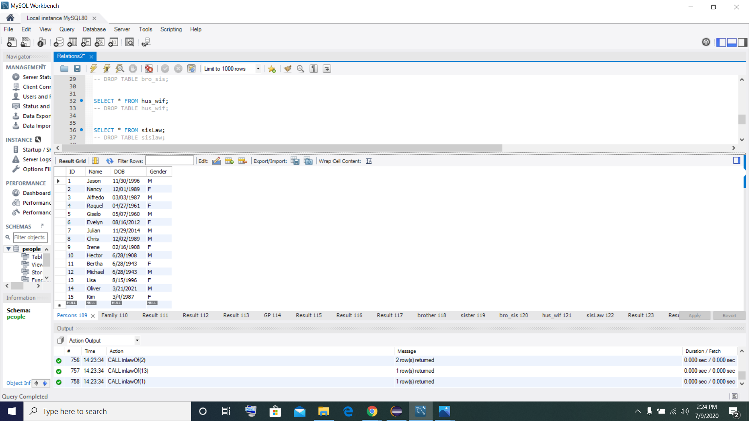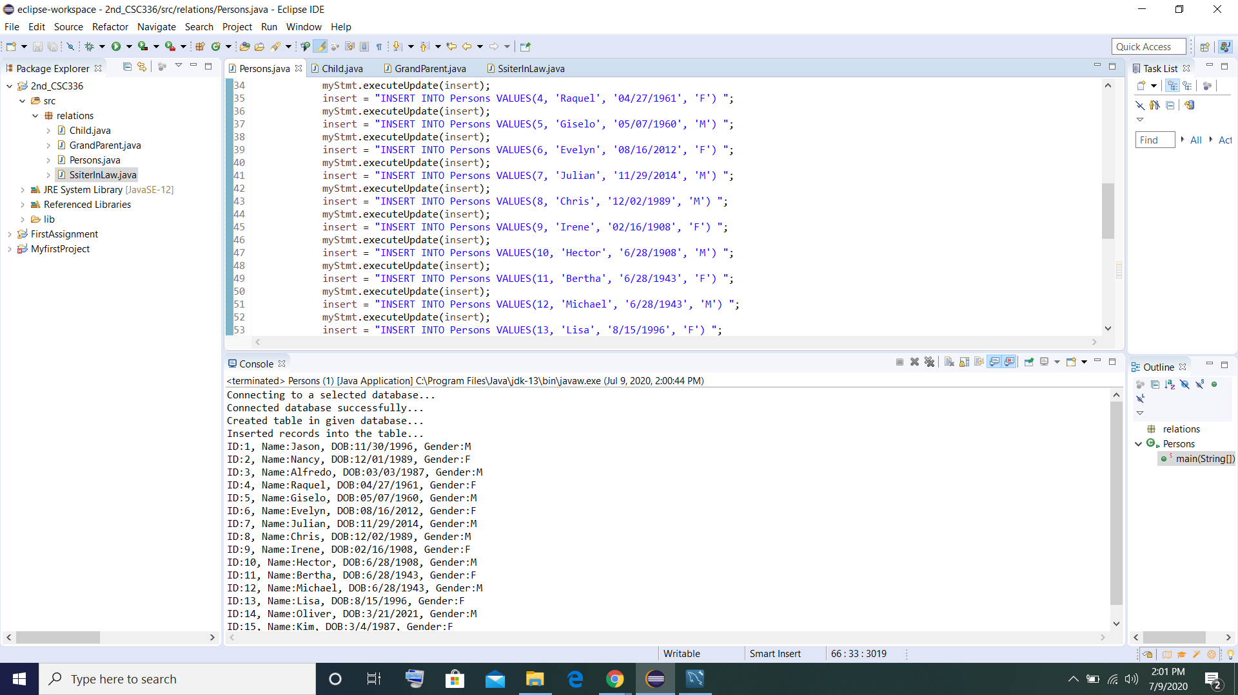

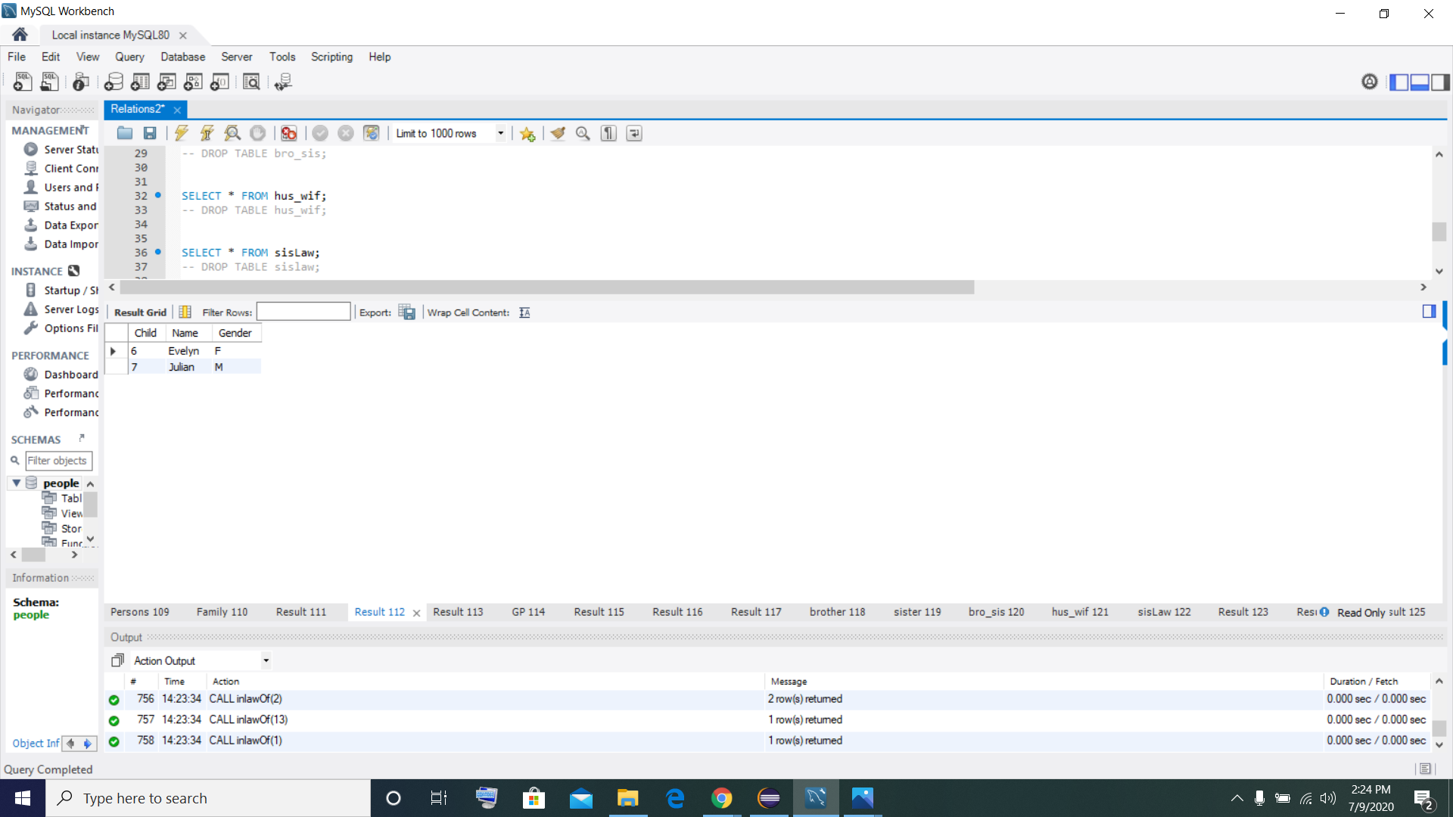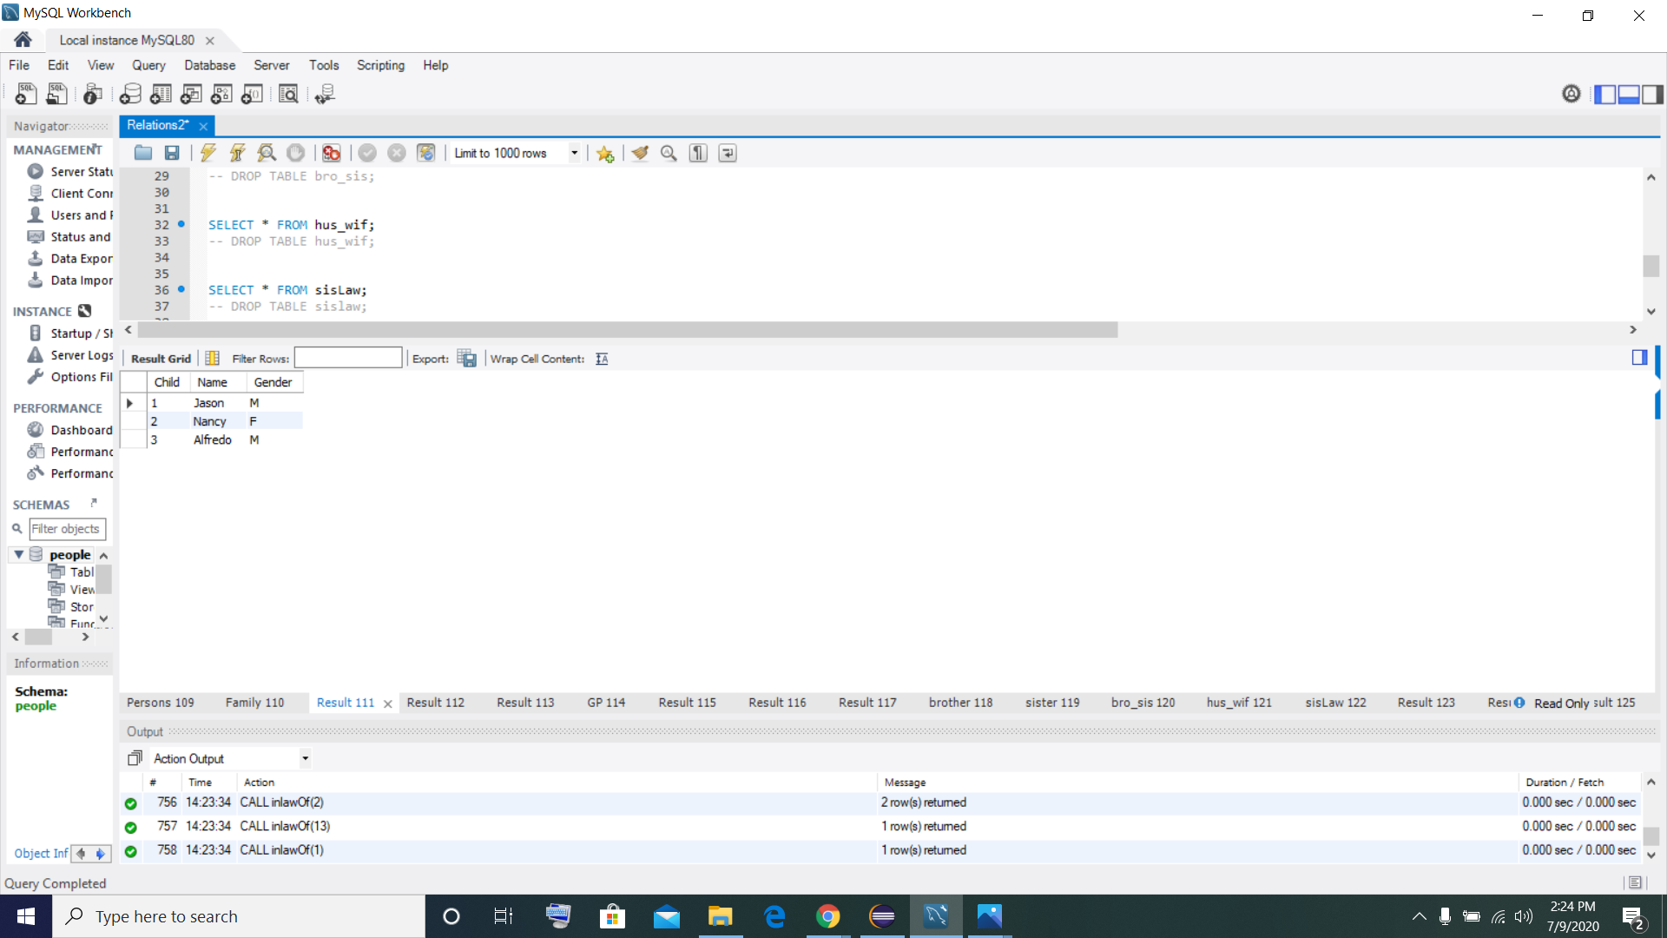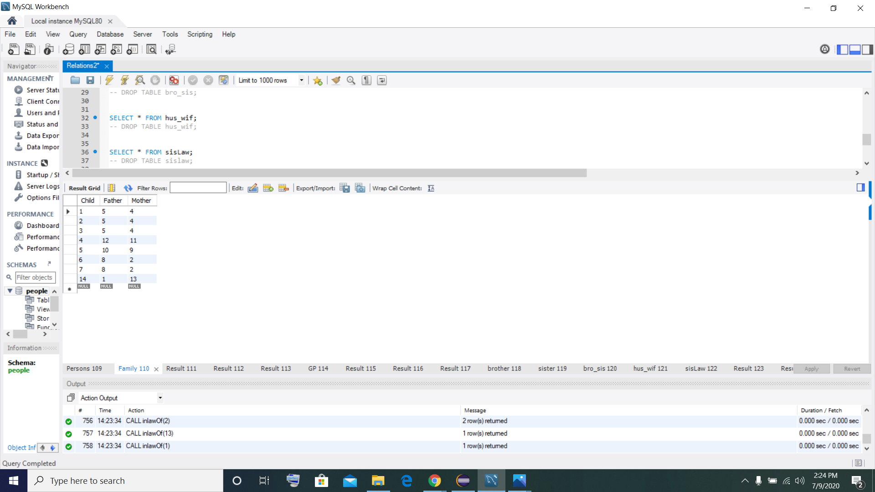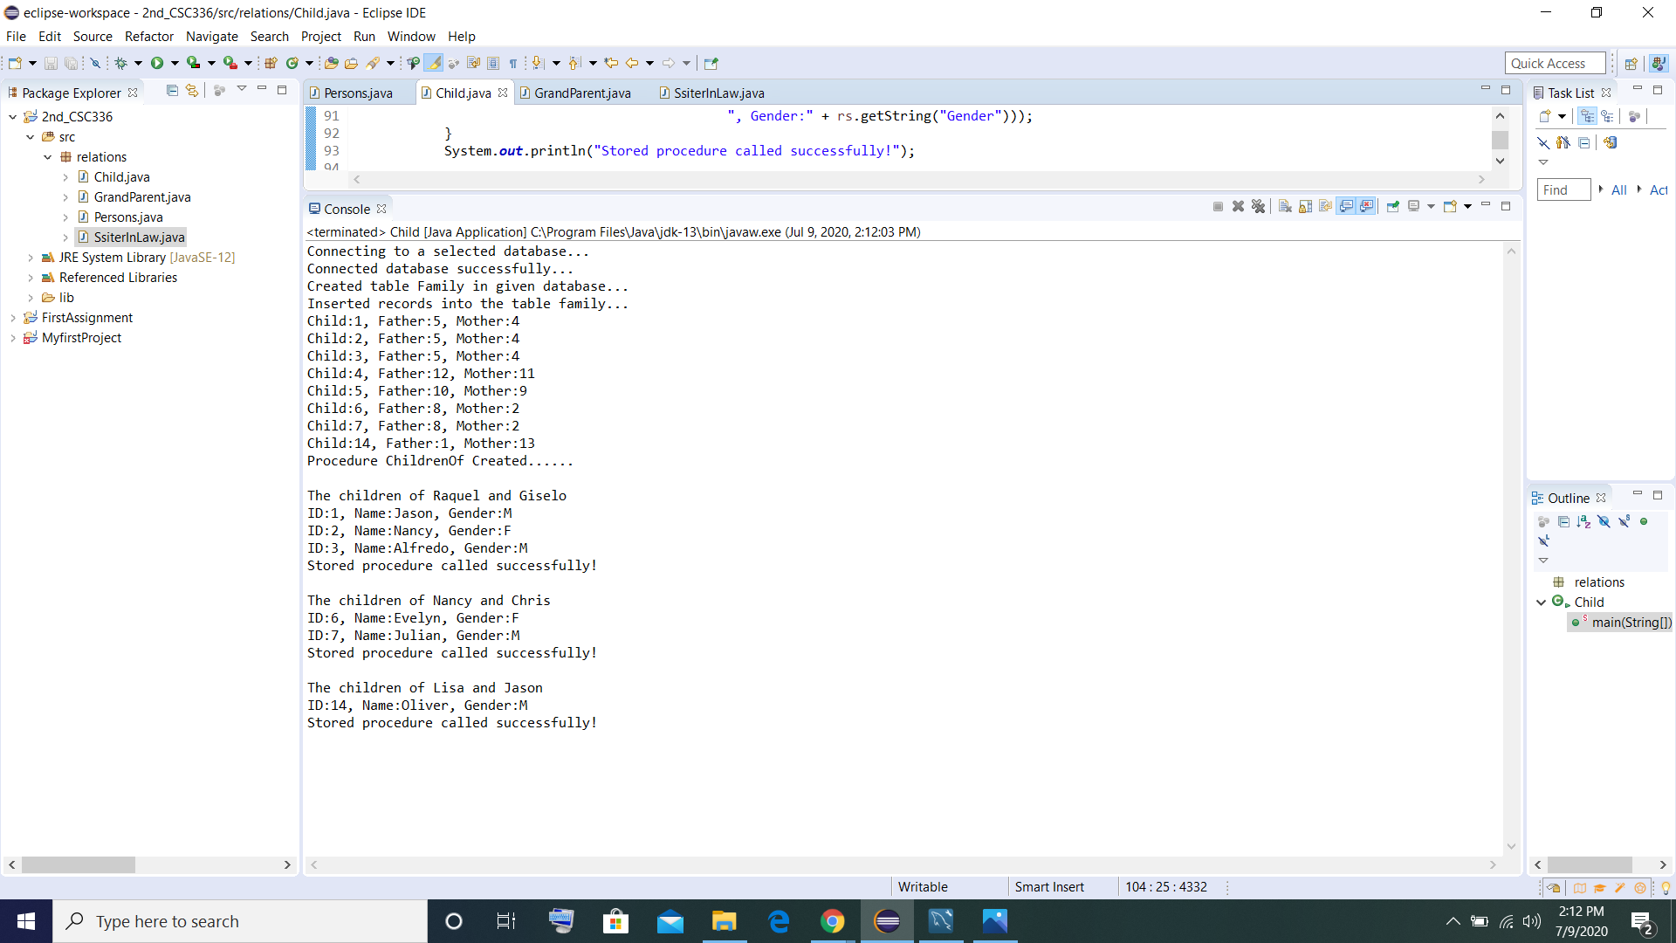

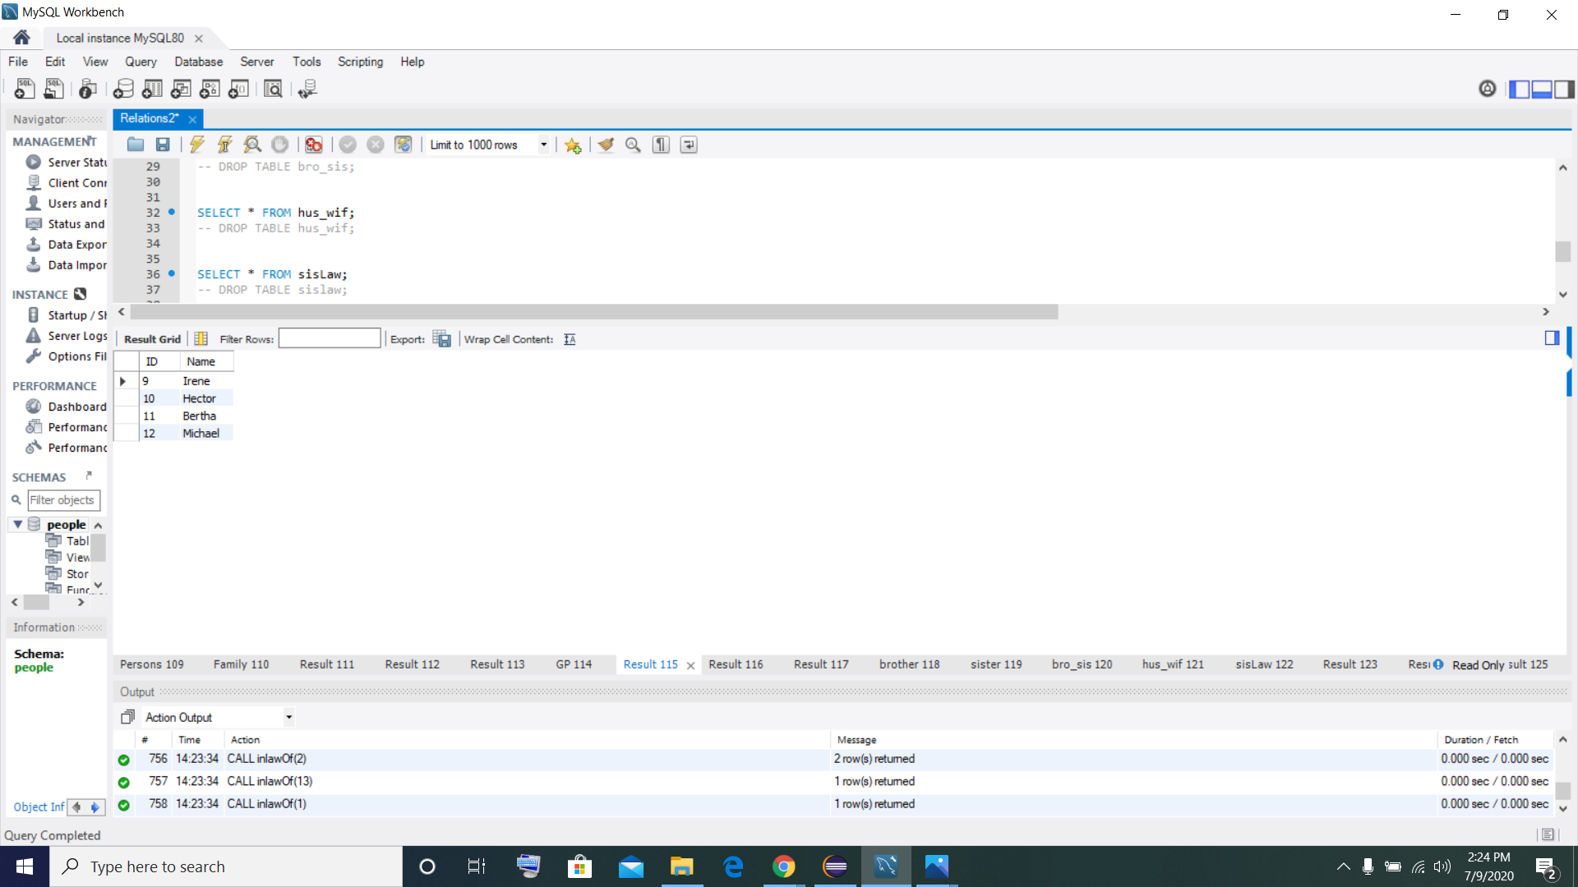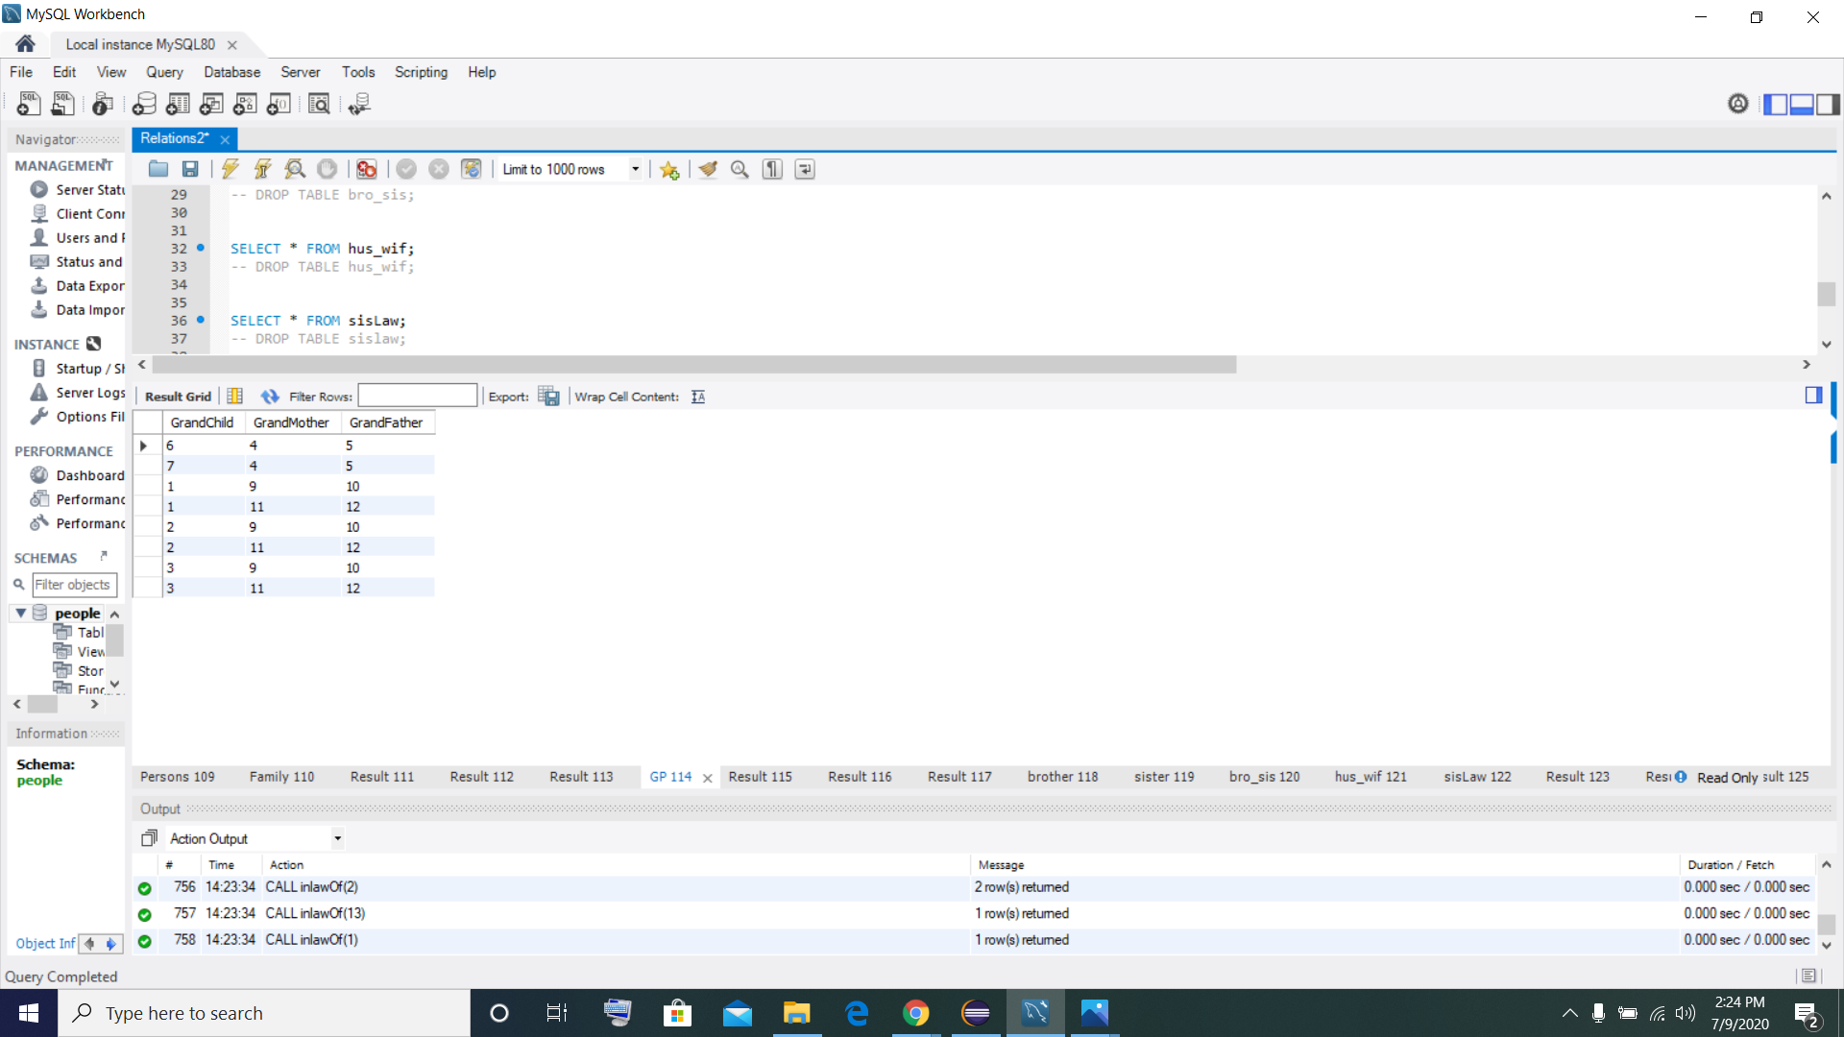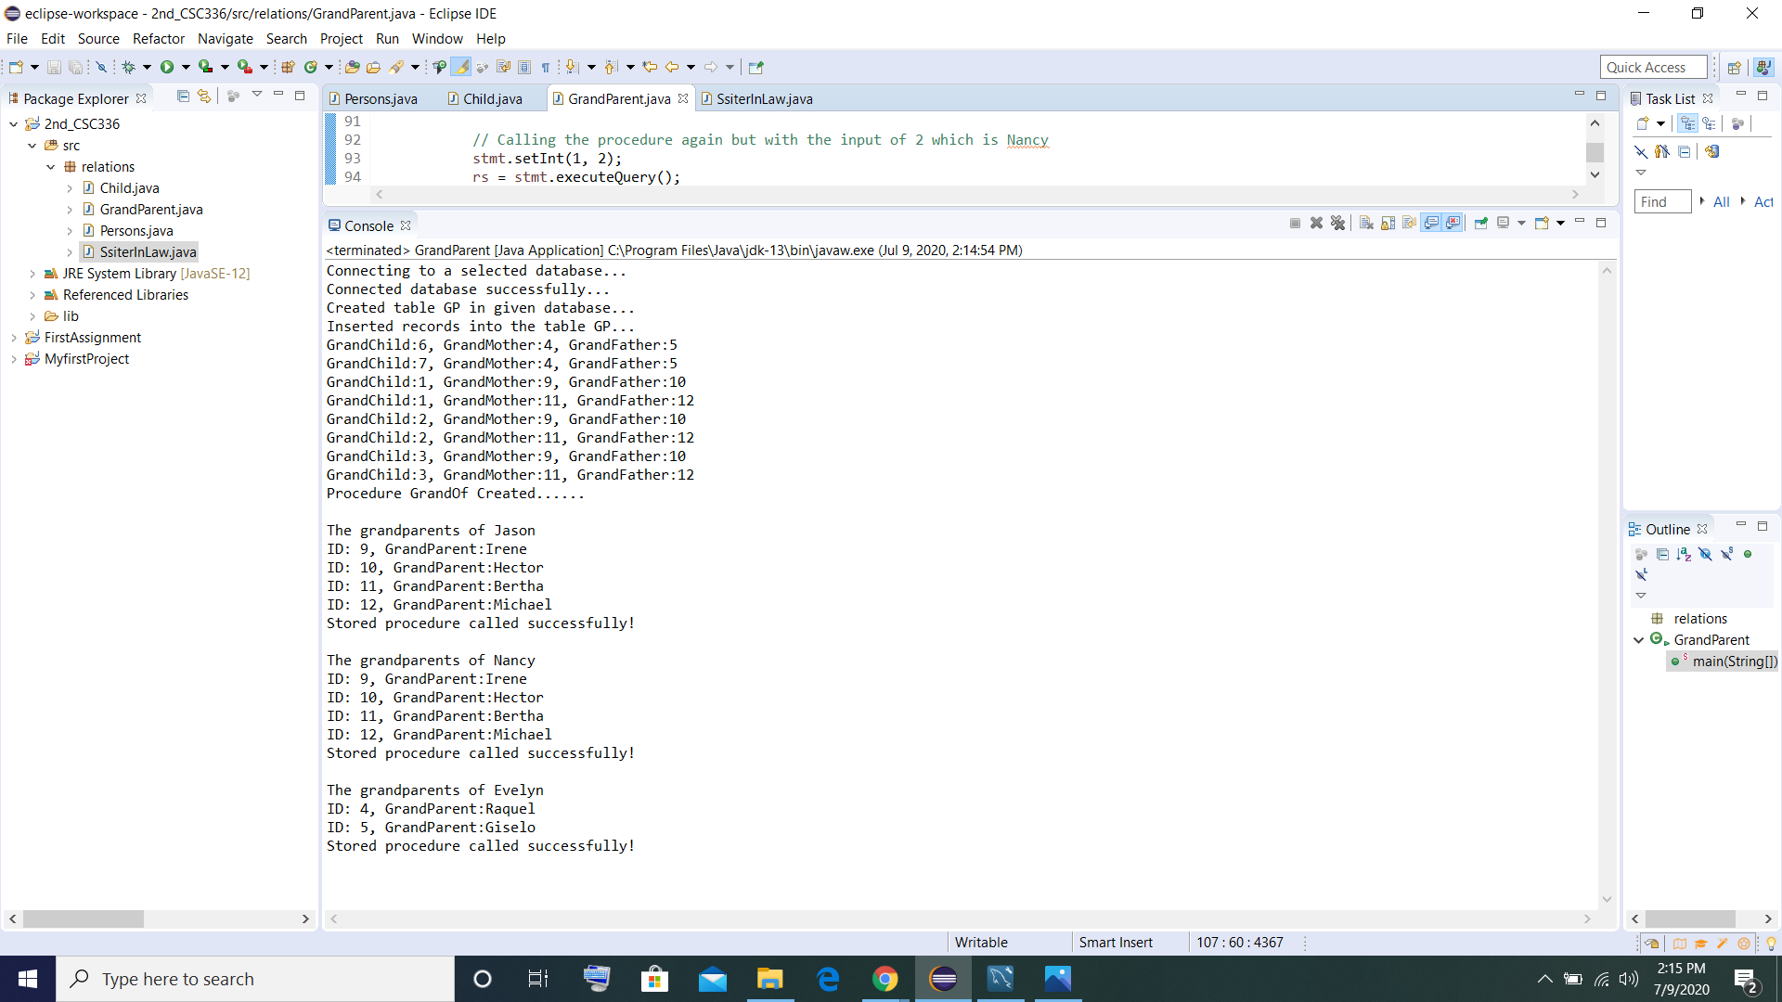

Output of the other tables that were not shown in the java application.

